Skills of listening and observing Learner’s name:
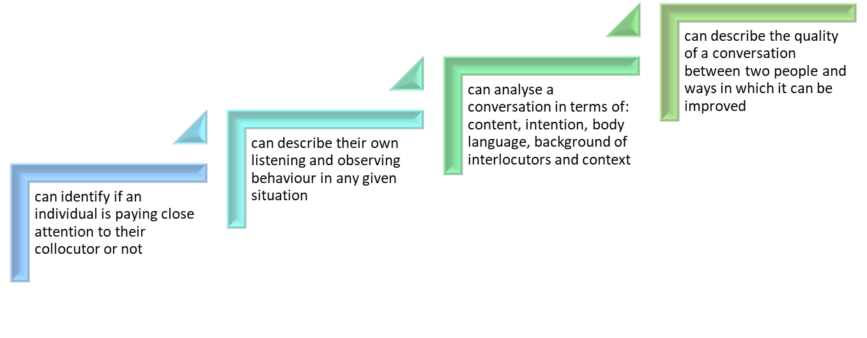
 | Achieved? | Achieved? | Achieved? | Achieved?
 | How? | How? | How? | How?

604699-EPP-1-2018-1-EL-EPPKA3-IPI-SOC-IN

This project has been funded with support from the European Commission. This publication reflects the views only of the authors, and the Commission cannot be held responsible for any use which may be made of the information contained therein

